Jennifer Weber
Exponential Hands-on Activity
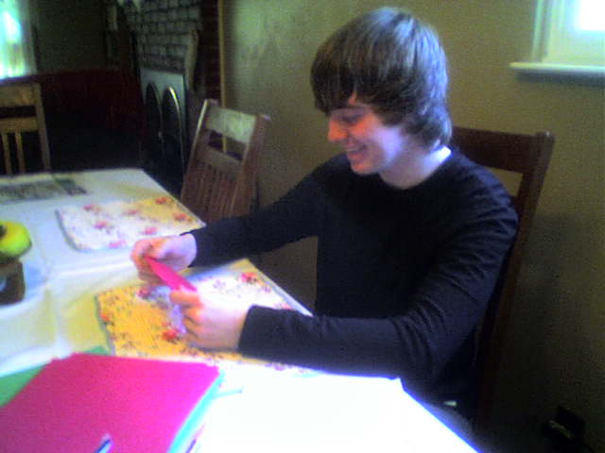
Investigating

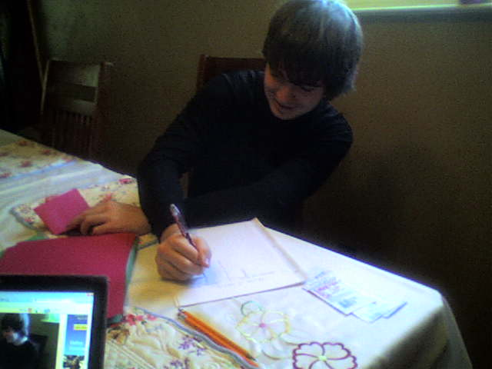
Documenting

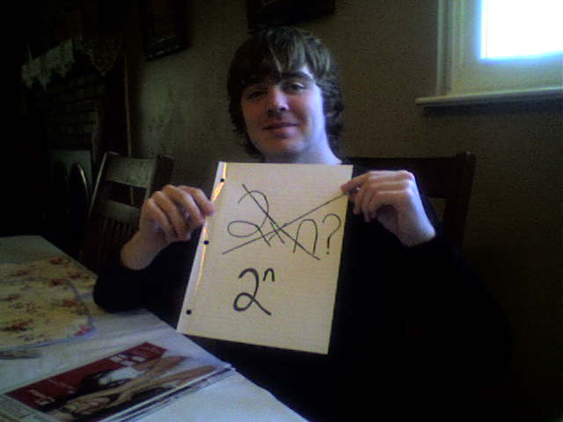
Discovering

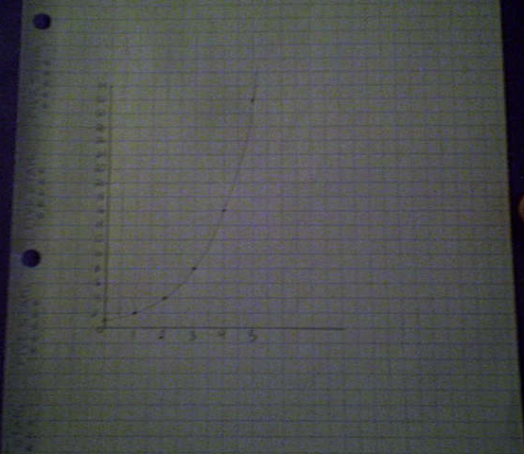
Making Connections

Exponential Models
This activity provides students with the opportunity to explore patterns of exponential models in tables, graphs, and symbolic form. Students will be able to apply what they learn to make bigger connections to ideas such as infinity and limits.

Necessary Prior Knowledge:
In order for this activity to have the most benefit, students should have prior knowledge of general exponential equations. Students should also have prior experience making tables and scatter plots. It is useful for students to know how to create scatter plots and graph models on the calculator but it can be incorporated in the lesson if necessary.

Goals:
- The student will be able to identify patterns of exponential growth and exponential decay.
- The student will be able to make accurate predictions based on real-life data.

Objectives:
- Given a table of data, the student will identify the mathematical model that best represents the data with 100% accuracy.
- Given a student created scatter plot and mathematical model, the student will predict future values with 100% accuracy.

Important terms:
Exponential growth: when a function increases by the same proportion at regular intervals
Exponential decay: when a function decreases by the same proportion at regular intervals

Key Formulas:
Exponential growth: $y=a*{(b)}^{n}$ for b > 1

Exponential decay: $y=a*{(b)}^{n}$ for b < 1

Note: a is the initial value and b is the rate of change

Materials:
- Paper (2 pieces per group)
- Graph paper (2 pieces per group)
- Paper Folding activity sheets (1 per student)
- Optional: Graphing Calculator (at least 1 per group)

Procedure:

- Setting up the Class
- Divide the class into pairs.

- Distribute the necessary materials to each pair of students (paper, graph paper, activity sheets, and calculator).

- Have each student follow along as you read the instructions located on their activity sheets.
  - Take time to answer any immediate questions.

- Explain that each pair of students has two roles: the recorder and the folder. Each student will have the opportunity to be each role since there are two activities. The recorder will write the information within the table on the activity sheet. The folder will follow the directions and fold the paper as necessary to fill-in the table. Have the students decide who will be designated the recorder in the first activity and who will be the folder in the first activity.

- Activity 1: Number of Rectangles

- Each pair of students should take one piece of paper. Each pair of students must determine the number of rectangles created per number of folds. First, each pair must determine have many rectangles there are when there are zero folds. The recorder will write the information in the table on the activity sheet.

- The folder will then fold the paper in half. Each pair of students must determine the number of rectangles the paper has after the fold has been made. The recorder will write the information in the table on the activity sheet.

- Each pair of students should repeat step 2 four more times. Each time the recorder will keep track of the number of folds and the corresponding number of rectangles created.

- Once the table has been created, have each pair of students discuss the possible mathematical model that would represent the pattern they see in their table.

- Discuss as a class what the possible mathematical model could be that would accurately represent the data.

- Have each pair of students create a scatter plot based on their data from their table.

- Have each pair of students draw a smooth curve to approximate the function.

- Discuss as a class what the graph looks like.

- Activity 2: Area of Smallest Rectangle Created

- Each pair of students should switch roles.

- Each pair of students should take the other piece of paper. Tell the students that the area of the piece of paper is 1 (pretend the paper has a length of 1 unit and a width of 1 unit). Each pair of students must determine the area of the smallest rectangle created per number of folds. First, each pair must determine the area of the smallest rectangle when there are zero folds. The new recorder will write the information in the table on the activity sheet.

- The new folder will then fold the paper in half. Each pair of students must determine the area of the smallest rectangle the paper has after the fold has been made. The recorder will write the information in the table on the activity sheet.

- Each pair of students should repeat step 3 four more times. Each time the recorder will keep track of the number of folds and the corresponding area of the smallest rectangle created.

- Once the table has been created, have each pair of students discuss the possible mathematical model that would represent the pattern they see in their table.

- Discuss as a class what the possible mathematical model could be that would accurately represent the data.

- Have each pair of students create a scatter plot based on their data from their table.

- Have each pair of students draw a smooth curve to approximate the function.

- Discuss as a class what the graph looks like and compare the graph to the graph created from the first data set (activity 1).

- Bigger Connections:
- What would be different if you tried Activity 1 with a sheet of tissue paper?

- What do you think would happen if you tried Activity 1 with a sheet of tissue paper that is as big as the room? Would the values in the table approach any particular number?

- What would happen if you tried Activity 2 with a sheet of tissue paper?

- What number do you think the values are approaching in Activity 2’s table?

- Will the values ever reach that number? Why or why not?

- Additional Practice:
Provide students with the following table:
Number of hours since you brushed your teeth | Population of bacteria in your mouth (in the thousands)
0 | 1
2 | 4
4 | 16
6 | 64
8 | 256
10 | 1024

- Create a scatterplot based on the information.

- What mathematical model would best represent the data in the table?

- Is this table an example of exponential growth or exponential decay?

- How much bacteria will be in your mouth after 24 hours have passed since you have last brushed your teeth?

Paper Folding Activity Worksheet

Activity 1: Number of Rectangles

Number of Folds | Number of Rectangles Created
0
1
2
3
4
5

- Take one 8.5 x 11” sheet of paper.

- Determine the number of rectangles created when you have zero folds.

- Record the data in the table above.

- Fold the sheet of paper in half and determine the number of rectangles created after you have made fold.

- Record this data in the table and continue in the same manner until the table is completed.

- Determine a mathematical model that represents the data by examining the patterns in the table.

- Create a scatter plot based on the data in the table (Use the graph paper attached).

- Draw a smooth curve on your scatter plot to approximate the function.

Activity 2: Area of Smallest Rectangle Created

Number of Folds | Area of Smallest Rectangle Created
0
1
2
3
4
5

- Take one 8.5 x 11” sheet of paper.

- Imagine this piece of paper has a length of 1 unit and a width of 1 unit. Determine the area of the smallest rectangle created when you have zero folds.

- Record the data in the table above.

- Fold the sheet of paper in half and determine the area of the smallest rectangle created after you have made fold.

- Record this data in the table and continue in the same manner until the table is completed.

- Determine a mathematical model that represents the data by examining the patterns in the table.

- Create a scatter plot based on the data in the table (Use the graph paper attached).

- Draw a smooth curve on your scatter plot to approximate the function.

Directions For Using the TI-82 to: Graph a Scatter Plot, Determine an Exponential Model, and Graph the Model

To enter data:

- On Calculator: STAT 1 : EDIT ENTER
(Clear all lists by using the up arrow button to go to the top and pushing clear.)

- Enter data with L1 as the independent variable and L2 as the dependent variable.

To plot scatter graph:

- On Calculator: 2nd Y (STAT PLOT) 1 : PLOT 1 ENTER
- Plot on; type scatter (1st).
- X list: L1; Y list: L2; Mark: 1st symbol.

To choose window and graph:

- On Calculator: ZOOM 9 : ZoomStat, ENTER
(Note: YOU SHOULD SEE A SCATTER PLOT.)

To find the exponential regression:

- On Calculator: STAT, CALC, A:ExpRe g, ENTER

To graph the line:

- On Calculator: Y =, VARS, 5 : Statistics, EQ 7:RegEQ, GRAPH
(Note: YOU SHOULD GET A CURVE THOUGH THE SCATTER PLOT.)

Works Cited

Area of smallest rectangle. (n.d.). Lesson plans. Retrieved April 29, 2012 from
http://www.pbs.org/teachers/mathline/lessonplans/pdf/hsmp/rhinos.pdf

Number of rectangles. (n.d.). Lesson plans. Retrieved April 29, 2012 from
http://www.pbs.org/teachers/mathline/lessonplans/pdf/hsmp/rhinos.pdf

Directions for using the TI-82. (n.d.) Lesson plans. Retrieved April 29, 2012 from
http://www.pbs.org/teachers/mathline/lessonplans/pdf/hsmp/rhinos.pdf

